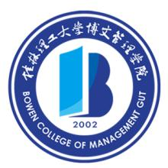

Regular Higher Education

Diploma

Li Mengwei, female, born on October 7th, 1994, was admitted to the International Economics and Trade major at this university in September 2012. By June 2016, she had successfully accomplished all the courses required by the four-year undergraduate program and earned enough credits. Thus, she is hereby granted graduation.

Bowen College of Management, Guilin University of Technology President: Wang Jinye

Certificate No.: 136451201605000884 Date: June 30th, 2016

_______________________________________________________________________________
For inquiry of certificates: http://www.chsi.com.cn by Ministry of Education of the People’s Republic of China

